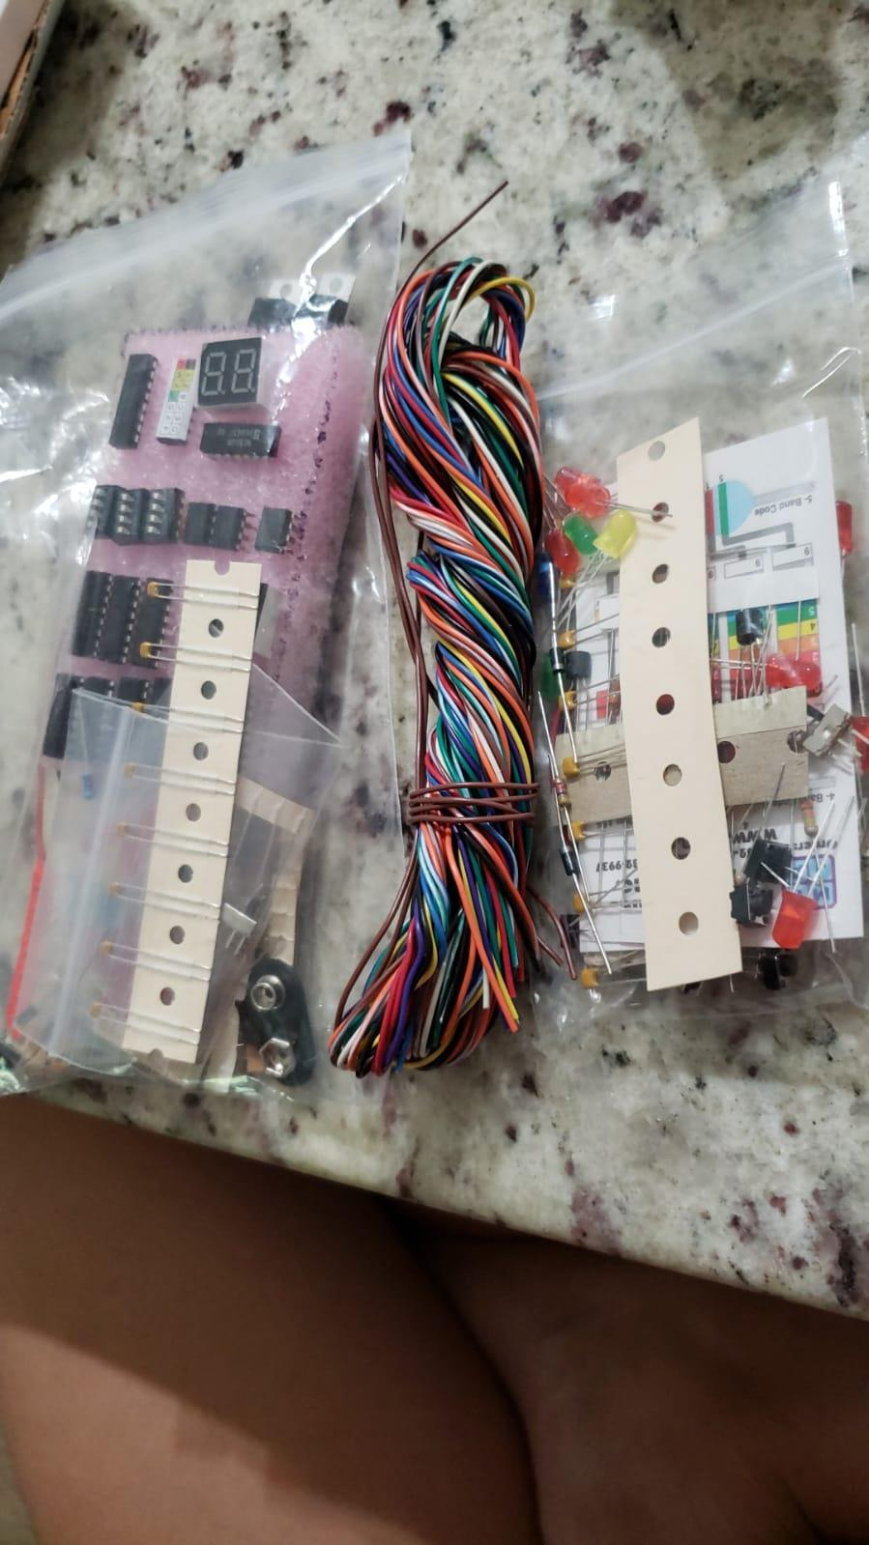
Roody Pointjour
CE PROJECT PORTFOLIO
LinkedIn: linked.com/roody-pointjour
Email: roody.jerry@yahoo.com
Computer Engineer

rpointjour.github.io/digital_business_card
2
Raspberry Pi BLE (A.G.I.S.)

Overview
The goal of this project was to build a Bluetooth Low Energy (BLE) system linking a Raspberry Pi to native phone and watch client apps. The Pi runs as a BLE GATT server, advertising services that a companion iOS, watchOS, or wearOS client discovers and connects to. The client sends requests over BLE GATT to trigger a relay-controlled DC motor, with live signal strength and distance feedback shown in the app.

Hardware
- Raspberry Pi (Linux / Debian)
- Relay Module
- DC Motor
- Breadboard + Touchscreen Display

Software
- Python (BLE GATT Server)
- Swift / Xcode (iOS, watchOS Client)
- Java / Android Studio (Android, wearOS Client)

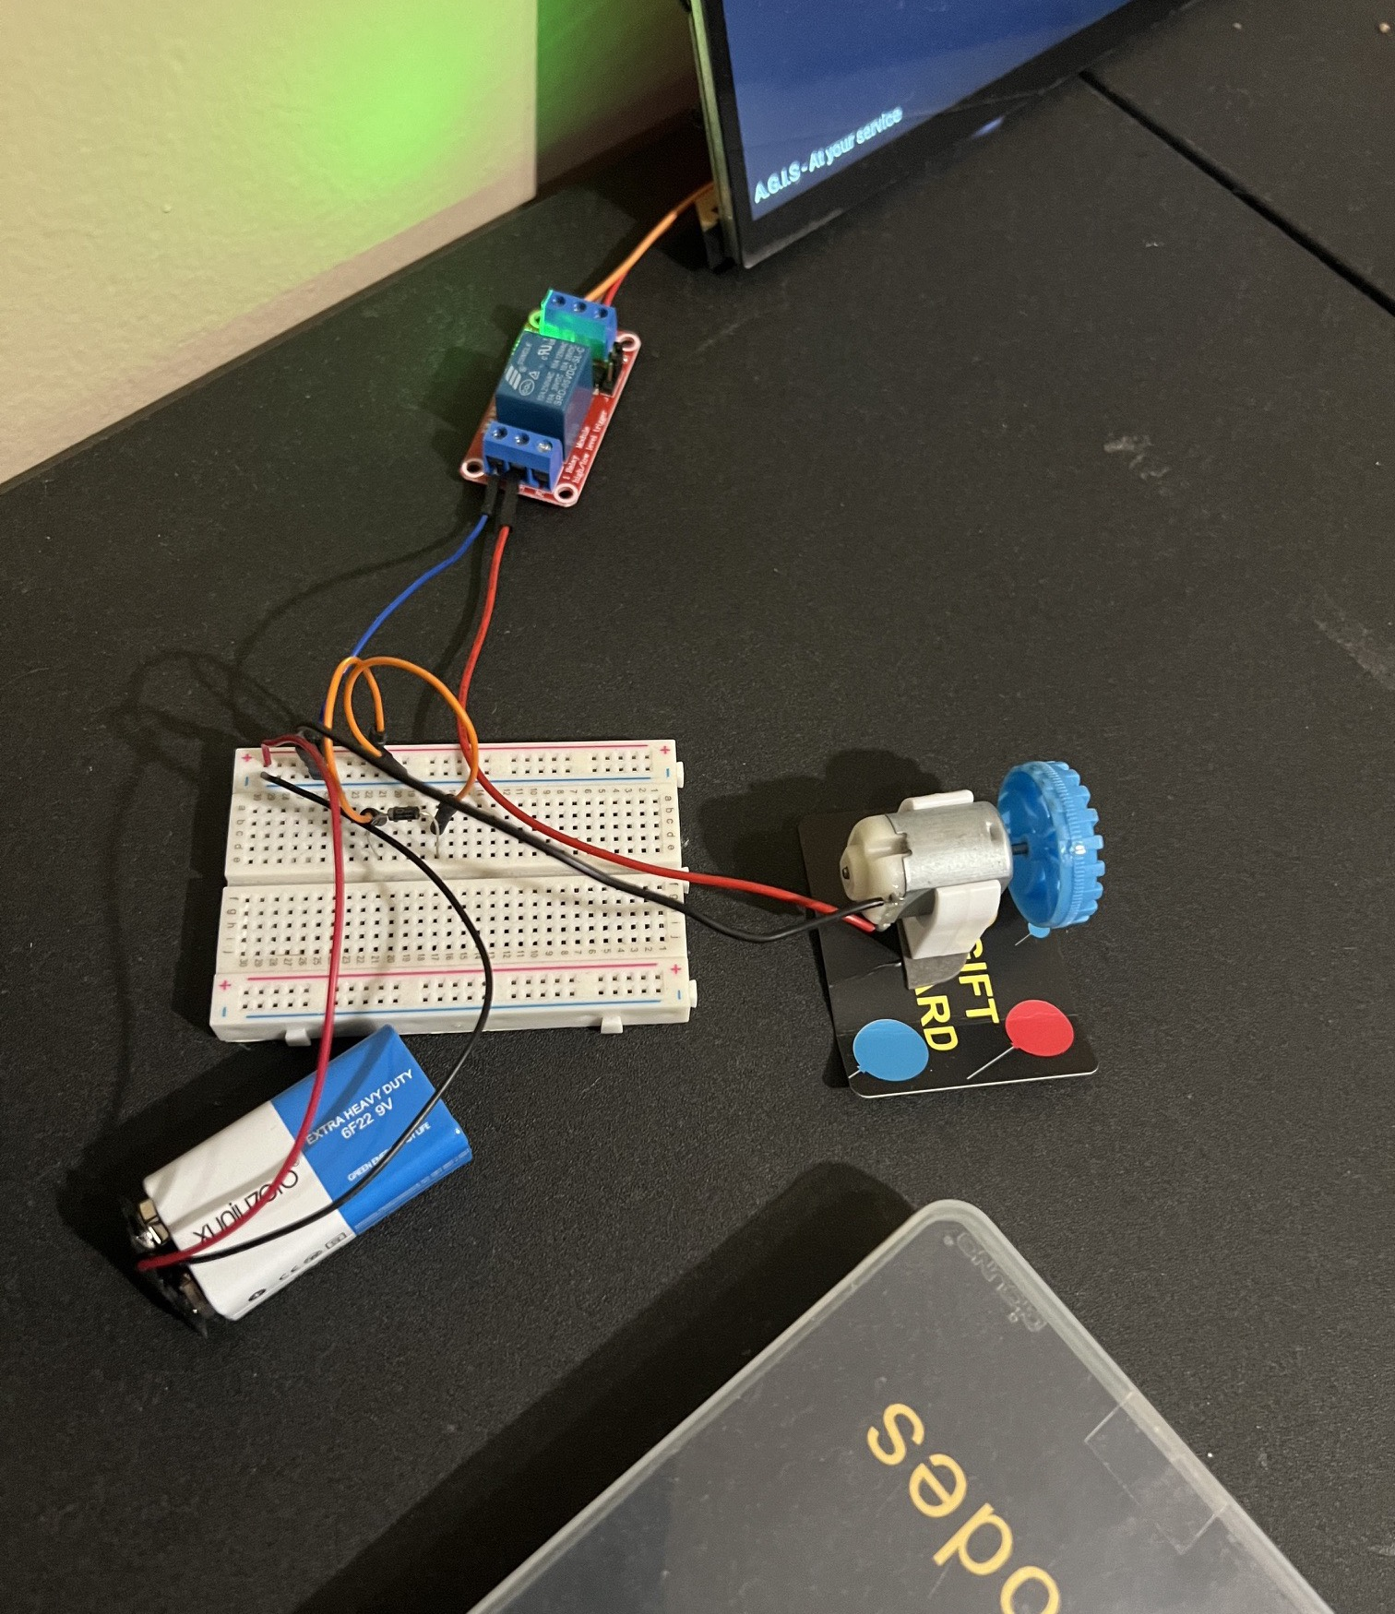 | 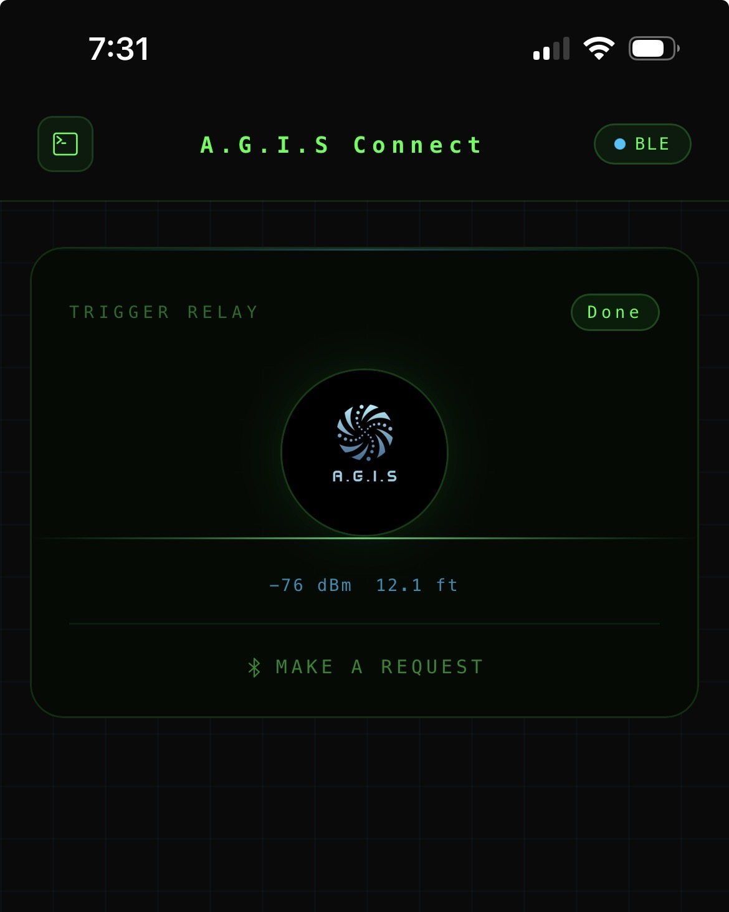

rpointjour.github.io/digital_business_card
3
TurtleBot3(Waffle Pi)

Overview
The goal of this project aimed to design and build a robot capable of autonomously following the dynamics of a leader. I worked together alongside my team to program the robot to follow a human. Basically, the follower in the leader-follower system, could track the trajectory of the leader without any collisions.

Hardware
- Remote Controller (Bluetooth, BLE)
- 360 Degree Laser Distance Sensor (for SLAM & Navigation)
- Sensors: Gyro, Accelerometer, IR Sensor, Motion Sensor, Distance Sensor

Software
- ROS - Robot Operating System
- SLAM - Used for mapping

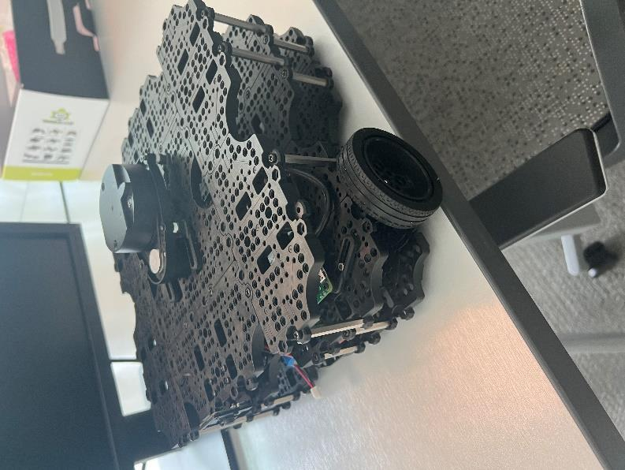 | 